Batch: B2 Roll No.: 1611103

Experiment / assignment / tutorial No._______

Grade: AA / AB / BB / BC / CC / CD /DD

Signature of the Staff In-charge with date

TITLE: Implementation of LRU Page Replacement Algorithm.

AIM: The LRU algorithm replaces the least recently used that is the last accessed memory block from user.
______________________________________________________________________
Expected OUTCOME of Experiment:

CO 4-Learn and evaluate memory organization and cache structure
___________________________________________________________________
Books/ Journals/ Websites referred:
- Carl Hamacher, Zvonko Vranesic and Safwat Zaky, “Computer Organization”, Fifth Edition, TataMcGraw-Hill.
- William Stallings, “Computer Organization and Architecture: Designing for Performance”, Eighth Edition, Pearson.
_____________________________________________________________________
Pre Lab/ Prior Concepts:

It follows a simple logic, while replacing it will replace that page which has least recently used out of all.
a) A hit is said to be occurred when a memory location requested is already in the cache.
b) When cache is not full, the number of blocks is added.
c) When cache is full, the block is replaced which is recently used
Algorithm:

- Start
- Get input as memory block to be added to cache
- Consider an element of the array
- If cache is not full, add element to the cache array
- If cache is full, check if element is already present
- If it is hit is incremented
- If not, element is added to cache removing least recently used element
- Repeat step 3 to 7 for remaining elements
- Display the cache at very instance of step 8
- Print hit ratio
- End

Example:

#include<iostream>
#define WINDOW 2
using namespace std;
int check(int a[],int r,int ele)
{
for(int i = 0;i<=r;i++)
{
if(a[i] == ele)
return i; //to Hid
}
if(r == WINDOW)
return 4; //delete last used element
else if(r<WINDOW)
return 5; //to just insert
}
void hid(int a[],int pos,int rp,int ele)
{
int temp = a[pos];
for(int i = pos;i<rp;i++)
a[i] = a[i+1];
a[rp] = temp;
}
int main()
{
int page[WINDOW+1],rp,LRU;
rp = -1;
int x = 0;
do
{
cout<<endl;
cout<<"Enter the number(-1 to quit) : ";
cin>>x;
cout<<endl;
if(x == -1)
break;
switch(check(page,rp,x))
{
case 5 : page[++rp] = x; //inserting
break;
case 4 : //del LRU n inserting
cout<<page[0]<<" is the least recently used.\nDeleting and inserting new page......\n";
for(int i =0;i<WINDOW;i++)
{
page[i] = page[i+1];
}
page[rp] = x;
break;
default : hid(page,check(page,rp,x),rp,x);
cout<<"Hit!!\n";
break;
}
LRU = page[0];
cout<<"The cache is : \n";
for(int j =0;j<=rp;j++)
cout<<page[j]<<"\t";
cout<<"\nLeast Recently Used Page : "<<LRU<<endl;
}while(x!=-1);
}

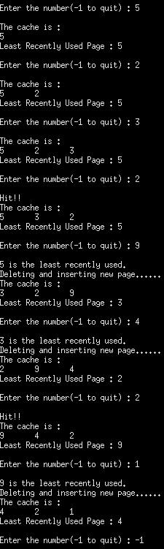

Post Lab Descriptive Questions (Add questions from examination point view)

1. Define hit rate and miss ratio?

Ans. Occurrence of Hit ─ in a level when the address
that an operation references is found in that
level of the memory hierarchy otherwise, a Miss
It is also defined as The chief measurement of a cache, which is the percentage of all accesses that are satisfied by the data in the cache.
The miss ratio is the fraction of accesses which are a miss. It holds that miss rate=1−hit rate. The (hit/miss) latency (AKA access time) is the time it takes to fetch the data in case of a hit/miss. If the access was a hit - this time is rather short because the data is already in the cache.

2. What is the need for virtual memory?

In computing, virtual memory is a memory management technique that is implemented using both hardware and software. It maps memory addresses used by a program, called virtual addresses, into physical addresses in computer memory. Main storage, as seen by a process or task, appears as a contiguous address space or collection of contiguous segments. The operating system manages virtual address spaces and the assignment of real memory to virtual memory. Address translation hardware in the CPU, often referred to as a memory management unit or MMU, automatically translates virtual addresses to physical addresses. Software within the operating system may extend these capabilities to provide a virtual address space that can exceed the capacity of real memory and thus reference more memory than is physically present in the computer.
The primary benefits of virtual memory include freeing applications from having to manage a shared memory space, increased security due to memory isolation, and being able to conceptually use more memory than might be physically available, using the technique of paging.

Conclusion
Hence the LRU algorithm for page replacement is studied and implemented in C++.

Date: _____________ Signature of faculty in-charge

